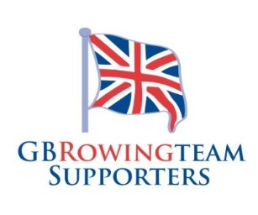
Membership & Renewal Application Form
Please send this application and any monies to the Treasurer:
Peter Hodge, The Grange, Hebden, Skipton, BD23 5DY

Name(s):
Postal Adress:
Postcode:
Telephone: |  |  | Landline:
Email: |  |  |  |  |  |  |  |  | (please print clearly)
Are you happy to receive updates by email? Yes (please tick)
Rower(s) supported
Rower’s name |  |  | Current squad |  |  |  |  |  | Relationship
Do you have any connections yourself with rowing? If so, what?
Would you be willing to help out with “GB Rowing Team Supporters”?
If so, what skills or expertise could you offer?
Would you be willing to be a link person for the squad that you support?(e.g. Junior, U23, Adaptive, Senior Women, Senior Men
How much time could you give?
As part of your membership, GB Rowing Team Supporters woulkd like to share your details (name and email) with carefully creened and rowing related third parties to allow you to access membershipo benefits, such as the GBRTS excluve kit. If you do not want your information to be used in this way, please tick the box.
Please complete this section, sign and return to Peter Hodge as mentioned above.
I wish to join/renew (please delete as necessary)
Annual membership £10 (annual membership 1 April – 31 March) OR Life membership £50
I enclose a cheque made payable to “GBRTS” OR
I have paid by BACS transfer to A/C No: 61483323, Sort Code: 40-42-06
Signed: Initials: Date:

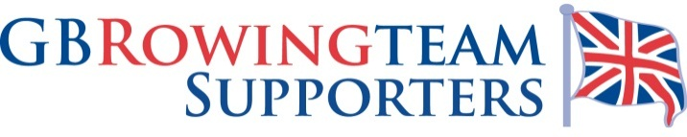
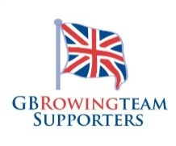
For more details please contact Peter Hodge on livandpeter4@gmail.com or fill in the membership form on the back of this flyer!
Membership to the GBRTS costs £10 annually, or
£50 for a life membership.

As well the benefits listed above, at the end of last season the GBRTS were able to give a donation to the Mark Lees Foundation - a charity that helps budding rowers.
There are many benefits of joining the GBRTS including;
• A quarterly Newsletter.
• Access to a Yahoo Group to keep you up to date and connected with other Supporters.
• The chance to buy official GBRTS clothing.
• Access to regatta venue information.
• Free personal name badges - so you can meet and recognise other Supporters at rowing events.
• And much more!
The GB Rowing Team Supporters (GBRTS) Need YOU!

